**Evaluation of a risk ranking of Irish salmon farms based on network metrics and biosecurity evaluation**

**Motivation and aims**

Salmon farming has been carried out in Ireland for more than 30 years. During the 10 year period 2001 – 2010 over 144,000 tons of salmon were sold at a value of above €594M. Salmon farming is therefore a significant contributor to the Irish economy, particularly along disadvantaged areas of the western seaboard. Since 2009 more than 65% of Irish farmed salmon has been sold as certified Organic (in 2012 was over 80%1) and, as a consequence, sales prices have been relatively high and stable. Nevertheless, national production still remains low compared with the first years of the previous decade, where it peaked around 23,000 tons, and the estimate for 2012 was 15,000 tons2.

As with other animal production settings, where animals are kept in confined environments with close interactions between each other, diseases are a major challenge. Currently, the most significant diseases in the Irish salmon farming industry are pancreas disease (PD) and amoebic gill disease (AGD). PD is an infectious viral disease of farmed salmonids, predominantly marine stage Atlantic salmon, *Salmo salar*, whose causal agent is an atypical alphavirus, the salmon pancreas disease virus (PDV) with the most serious impacts reported in Ireland, Norway and Scotland. Infection with these viruses can lead to clinical disease due to acinar pancreatic necrosis and fibrosis as well as a range of myopathies (cardiac, skeletal, esophageal) 3. The level of mortality on PD affected farms varies significantly with some experiencing a mortality of less than 5% for the whole rearing cycle whereas other farms may lose up to 40% of all stock over a 3 or 4 month period3.

The movement of animals and animal products is one of the most important means for disease spread. Live fish transport through well boats has been implicated in facilitating the spread of infectious salmon anemia (ISA) in Scotland 4 and Chile 5, and road haulage of live rainbow trout was implicated in the spread of bacterial kidney disease (BKD) in UK wide in 2005 6. Biosecurity is another important factor in determining farm vulnerability for disease introduction and spread. In aquaculture, biosecurity has been defined as the sum of all procedures in place to protect living organisms from contracting, carrying, and spreading diseases and other non-desirable health conditions 7. Effective biosecurity strategies provide protection to both farmed and wild aquatic animal populations, by minimizing the risk of introducing pathogens and minimizing the consequences or further spread if the pathogen was introduced8. Nevertheless, metrics of animal fish movement and farm biosecurity have seldom (if ever) been used as inputs for risk ranking and risk based surveillance of fish farms.

The first aim of this project is to integrate a farm’s interaction with the farms in the rest of the country, via live fish movement, and a farm’s biosecurity into a sensible metric for risk ranking of salmonid farms in the country. The second aim is to validate this new metric by evaluating its association with the occurrence of PD outbreaks at the farm level.

This could provide insights for decision making, specifically for the design and implementation of risk based disease surveillance and control strategies.

**Study design**

It is appropriate to give a short introduction to elements of the modern production cycle of salmon that are important for the present study design. Juvenile salmons are hatched and reared in freshwater until the smolt stage. As smolts they are moved to net pens in the sea. Smolts are either put to sea in the autumn when they may be less than a year old (autumn smolts), or they are put to sea in spring or early summer when they are 1+ years old (spring smolts). Transport of smolts from freshwater rearing facilities to marine sites is mainly by well boats with open tanks. The fish are on-grown in the net pens for about 18 months, but this time-period varies. The fish are then normally shipped by well boats in open tanks to a processing plant. Although keeping different year-classes of fish on different sites is a common recommendation to prevent disease, this is not the case in Ireland, due to limited site licenses. Hence while some marine farms have a single year class per site, many don’t having a constant inflow of susceptible fish (smolts) to the farm. Also, movement of fish to new sites during their on growing period at sea is common. After slaughtering, it is recommended that sites should be fallowed for a period before a new production cycle is initiated, but in Ireland this is not always done for the reasons explained above.

The design of this study will be a retrospective cohort study, where the unit of analysis is the cohort of smolts stocked at the fish farm, exposures is the risk ranking for disease introduction of the farm itself and the risk ranking for disease spread of the smolt provider(s) (ordinal variable with 3 levels: low, medium, and high). The outcome of interest is clinical detection (i.e. outbreak) of PD. The period to be covered will be from January 2009 through December 2015.

A fish farm will be considered at risk from the first time it was stocked with smolts since follow up started (January 2009) and until 18 months from the last stocking date or until end of follow up (December 2015) if successive stocking of fish no more than 18 months apart occurred. If more than 18 months elapsed between two different groups of smolts being stocked, all the time beyond 18 months and before stocking will not be considered at risk. If the farm experiences and outbreak of PD it will no longer accrue time at risk until stocked again with (susceptible) smolts.

As the Irish salmon farming industry is small (from January 2009 through December 2015 there were 28 sites stocked with smolts, of which only 17 were stocked on different years), evaluation of potential confounders will be made on the basis of subject matter knowledge, literature review, and use of direct acyclic graphs (DAGS), instead of statistical screening. We anticipate that we will not be able to control for more than one or two confounders before the estimates become unstable or we face model convergence issues.

**Samples/Measurements:**

Biosecurity data was obtained from veterinary inspections that officers of the Irish Department of Agriculture Food and the Marine perform on salmonid fish farms on a regular basis. Frequency of inspection varies between every 1 to 3 years, depending on the a priori perceived risk of a farm. These inspections include 24 items related to biosecurity for freshwater farms and 20 for seawater farms, and are part of a wider statutory farm audit. Results from these inspections were summarized into a biosecurity score for each farm ranging from 0 to 10, where 0 means a farm did not comply to any of the audited measures, while 10 means the farm was fully compliant. Farm centrality measures were estimated from the finfish movement database provided by the Irish Marine Institute. This data base included origin and destination sites, coordinates, quantity, species, and stage of development. With these data node centrality measures were estimated, namely in-degree, out-degree, incloseness, outcloseness and betweenness.

For integrating the fish farms’ biosecurity characteristics and centrality measures into a risk ranking, a data reduction approach was taken. Using principal component analysis a farm biosecurity score and farm centrality measures (namely degree, closeness and betweenness) were reduced into two main components: the first one loaded heavily on centrality measures (-0.61, -0.54, and -0.48 for the measures mentioned above, respectively), and accounted for 50.4% of the total variability, while the second component loaded heavily on the biosecurity score (0.92) while accounting for 24.5% of the variability in the data set. With these 2 components the risk ranking was built, where high risk farms were those where both the first and second components were below zero (Figure 1, quadrant IV), low risk farms were those where both components were above zero (Figure 1 quadrant II), and medium risk farms were those where the two components had different sign (Figure 1, quadrants I and III). For the risk of the disease spread, results obtained and their interpretation is similar (Figure 1)

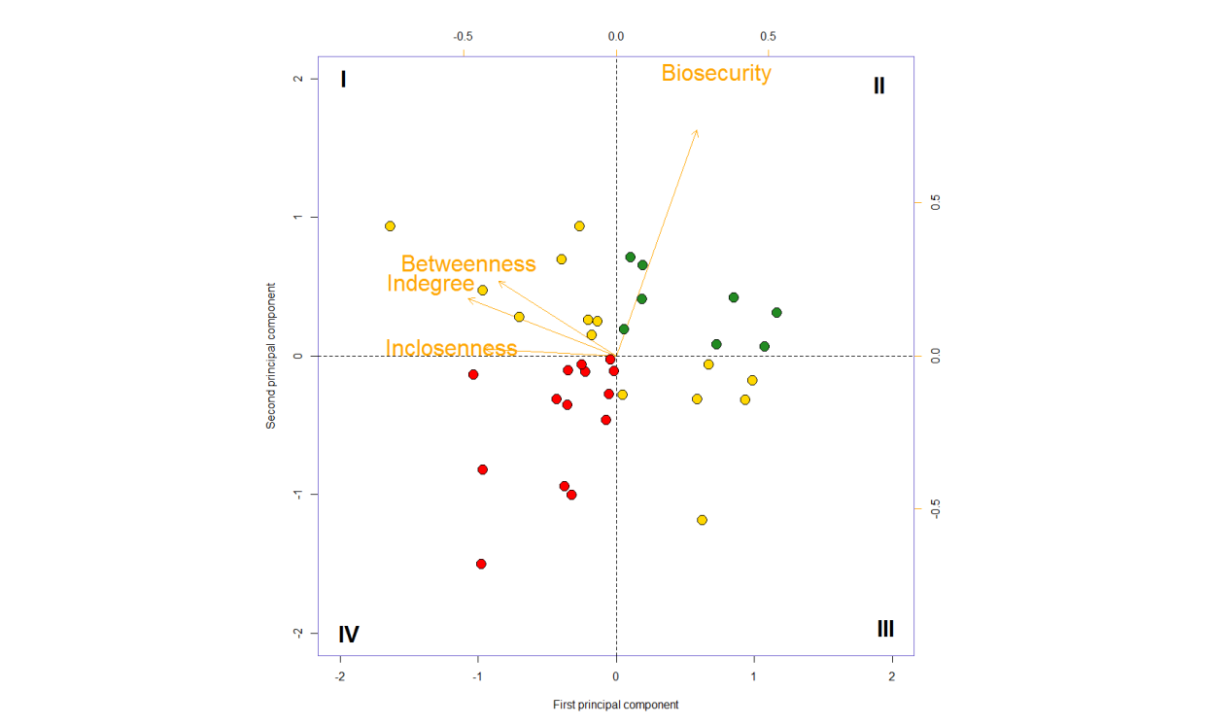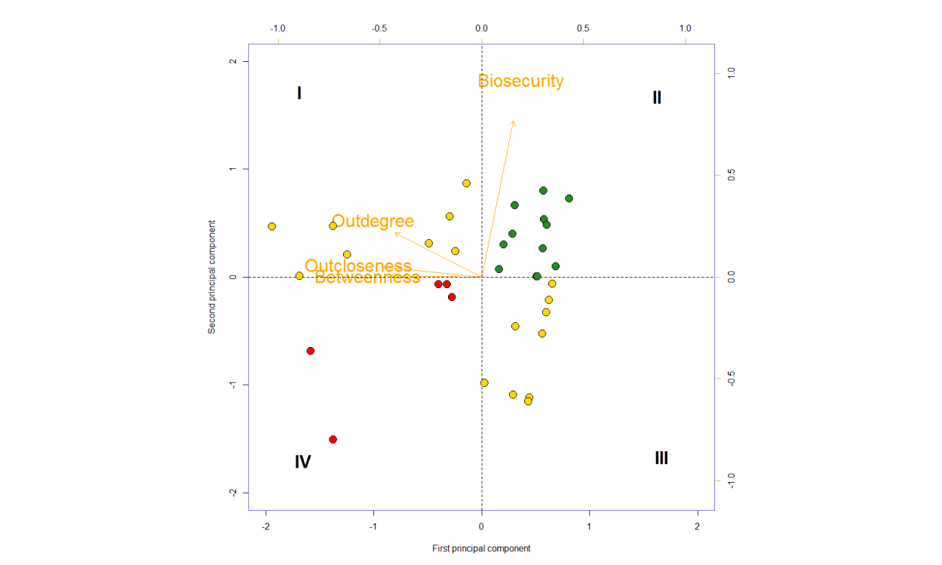

Figure 1. Principal component analysis for estimating the rank of Irish salmon farms for the risk of disease introduction (left) and spread (right) for 2013.

Although this has only been done for the years 2013 and 2014 (results not shown here), we expect to carry out the same analysis for the remainder of the study period. For the year where no veterinary inspection was carried out (and hence with no biosecurity score), the closest in time (either before or after) will be assumed to hold and used for the PCA and risk ranking estimation.

**Statistical analysis plan**

Descriptive statistics of the risk of outbreak occurrence (mean and variance, stratified by risk ranking of the farms) will be estimated for each year of the study period and time plots will be produced.

The risk of cohort of fish experiencing an outbreak will be modeled using a logistic regression model of the form

$$\operatorname{logit}\left(Y_{ij} | X_{ij},b_{i}\right)=β_{1}+β_{2}{Rank}_{ij}+ β_{3}{Time}_{ij}+β_{4}{Rank}_{ij}*{Time}_{ij}+b_{i}$$

Where $Y_{ij}$ is the probability of experiencing an outbreak in farm i at time j, $β$ is the vector of regression coefficients, ${Rank}_{ij}$ is the risk rank of farm i at time j, ${Time}_{ij}$ is the jth time since stocking at farm I, and $b_{i}$ a random effect for farm, which is assumed to be $N (0, σ_{b}^{2})$.

**N or power calculation**

For this study we will assume, based on preliminary results from this project, that smolts stocked in a high risk farm have a risk of developing an outbreak of PD of 90%, while smolts in a not-high risk farm (i.e. medium or low risk)) have a risk of 60%. The estimated number of smolt cohorts per risk group (high vs not-high) for detecting such a difference with a 95% confidence, and a power of 80%, will be based on the formula for comparing proportions9

Which was adjusted to account for within farm correlation in the risk ($ρ$), which is believed to be high, and hence was set to 0.75, using the formula below9

Where m is the cluster size. Here the number of cohorts per site varied between 5 and 1, so we use the average cluster size, which is 2.25.

$$n^{'}=\left(1+\left(2.25-1\right)*0.75\right)*31.46=53.1≈54$$

Hence the total number of cohorts required for the desired power will be 108, and only taking into account one main effect. My estimation is that I will be having no more than 75 cohorts of fish, which will provide a power of 60% for detecting such a difference, provided exposure groups are balanced and no adjustment for confounding is done. This seems like a tough cookie.

1. BIM, *Annual Aquaculture Survey 2013*, Food and the Marine Department of Agriculture, Editor. 2013, Bord Iascaigh Mhara, Irish Sea Fisheries Board: Dublin, Ireland. p. 16.

2. Marine Institute, *Farmed Salmon Health Review*, Marine Institute, Editor. 2014, Marine Institute: Galway, Ireland.

3. H. Rodger and S. Mitchell, *Epidemiological observations of pancreas disease of farmed Atlantic salmon, Salmo salar L., in Ireland.* J. Fish Dis., 2007. **30**(3): p. 157-67.

4. A. G. Murray, R. J. Smith, and R. M. Stagg, *Shipping and the spread of infectious salmon anemia in Scottish aquaculture.* Emerg. Infect. Dis., 2002. **8**(1): p. 1-5.

5. F. O. Mardones, et al., *The role of fish movements and the spread of infectious salmon anemia virus (ISAV) in Chile, 2007-2009.* Preventive Veterinary Medicine, 2014(0).

6. D. M. Green, A. Gregory, and L. A. Munro, *Small- and large-scale network structure of live fish movements in Scotland.* Prev. Vet. Med., 2009. **91**(2-4): p. 261-9.

7. Gary D. Pruder, *Biosecurity: application in aquaculture.* Aquacultural Engineering, 2004. **32**(1): p. 3-10.

8. B. C. Oidtmann, et al., *International and national biosecurity strategies in aquatic animal health.* Aquaculture, 2011. **320**(1–2): p. 22-33.

9. I. Dohoo, W. Martin, and H. Stryhn, *Veterinary Epidemiologic Research*. 2 ed. 2010, Charlottetown: VER Inc. 865.